NEW REPORT BY BBI JU SHOWS THE CONTRIBUTION OF ITS PROJECTS TO THE SDGS

*12 December 2019*

**A new study by the Bio-based Industries Joint Undertaking (BBI JU) summarises the contribution of its projects to the Sustainable Development Goals (SDGs) established by the United Nations (UN). The majority of BBI JU’s projects reported a contribution to the SDG 12 ‘Responsible Consumption & Production’, SDG 13 ‘Climate Action’, and SDG 9 ‘Industry, Innovation & Infrastructure’. A high number of projects also mentioned their contribution to the SDG 8 ‘Decent Work & Economic Growth’, and SDG 3 ‘Good Health & Well-Being’.**

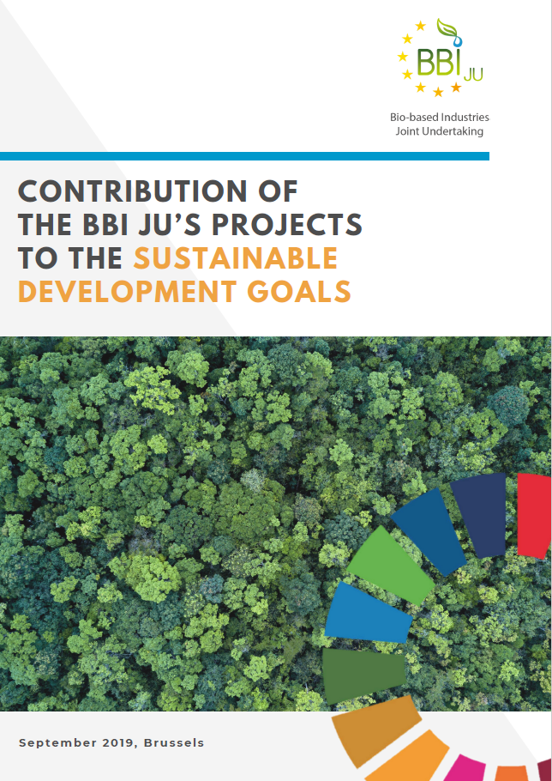The European Union’s sustainable development strategy includes the 17 SDGs defined by the UN as the targets to reach by the end of 2030. This study shows how the BBI JU granted projects contribute to the SDGs mainly by promoting sustainable industrialisation and sustainable economic growth. Other key contributions are the replacement of fossil-based products and improving the opportunities to feed the world under challenging climatic conditions. The report also reflects how the BBI JU projects create new jobs in rural areas while preserving the biodiversity and the beauty of nature.

This study details the contribution of different types of BBI JU actions to the relevant SDGs. The flagship biorefinery projects are contributing to a large extent to promoting sustainable agriculture and energy consumption. At the same time, flagship projects are combating desertification, land degradation and the loss of biodiversity in areas where biorefineries are located. For instance, the [LIGNOFLAG](https://www.bbi-europe.eu/projects/lignoflag) flagship project is contributing to the SDG 13 ‘Climate Action’ by producing bio-based ethanol that is expected to reduce the CO2 emissions up to 95%, compared to its fossil-based equivalents.

When it comes to BBI JU Demonstration Actions, an illustrative example is the contribution of the [Dendromass4Europe](https://www.bbi-europe.eu/projects/dendromass4europe) project to SDG 12 ‘Responsible Consumption and Production’. The project is developing an effective and sustainable way of using natural resources for the packaging industry while adding value to forestry resources without burning or mulching them.

All the SDGs have been mentioned at least once in the reporting by the projects, and at least ten BBI JU projects reported a contribution to as many as 12 SDGs. The study describes the contribution of the granted BBI JU projects at the end of 2018.

Find the full report [here](https://www.bbi-europe.eu/sites/default/files/media/bbi-ju-contribution-to-sdgs.pdf).